The DNA Code of Centennial Enterprises Uncovered

—— How to Build Enterprise Longevity Genes Under Supply-side Structural Reform
Author: Li XiaolinAffiliation: Zhong'an Chuanggu Science and Technology Park

Abstract
Under the background of supply-side structural reform, this paper focuses on how to build enterprise longevity genes. Borrowing the idea of biological DNA, it proposes that corporate DNA is the core genetic code that determines enterprise form, development scale, operational health and life cycle. An enterprise should take growth and creating value for customers as its original goal, rather than simply pursuing profit maximization.
The core value of corporate DNA theory can provide senior enterprise executives with an operational diagnosis and analysis framework to judge enterprise status such as health and sub-health. The key to a longevity enterprise lies in cultivating high-quality innate genes and adhering to the law of survival of the fittest for acquired evolution. Enterprises can also modify genes, introduce strategic investors, replace professional managers, restructure through capital market and other means to renovate genes and achieve long-term development.
Taking German centennial enterprises and hidden champions as benchmark samples, this paper summarizes the genetic characteristics of benchmark enterprises: most of them are family-run, adhere to niche strategy, deeply cultivate segmented fields, take quality as the core, attach importance to innovation and reform, cultural inheritance, efficient execution and leadership construction, and become the backbone of economic development. Meanwhile, it points out that innovation gene is the core of enterprise inheritance. By reconstructing corporate DNA, reorganizing production factors and reshaping value, enterprises can adapt to market competition and the general trend of mass entrepreneurship and innovation.
Drawing on the nucleotide combination logic of biological DNA, the four core systems of corporate DNA consist of organizational structure, information transmission, adaptation and incentive mechanism, and command and decision-making system, which are the foundation of enterprise vitality:Organizational structure system: prone to problems such as redundant management levels, narrow management span, insufficient authorization, high management cost and slow market response; improvements can be achieved by streamlining levels, clarifying specifications, optimizing promotion and carrying out management training.Information transmission system: focuses on the inheritance of corporate culture and values, solves pain points such as poor information circulation and divorced business plans, and improves operational efficiency by dividing independent business units and delegating planning and decision-making power.Adaptation and incentive mechanism: aiming at distorted performance evaluation, unreasonable assessment standards and imprudent investment decision-making, establish quantitative scorecards and bind decision-makers' interests to stimulate the vitality of employees and management.Command and decision-making system: solve problems such as ambiguous power and responsibility, arbitrary decision changes, poor cross-departmental collaboration and absence of authorization; clarify decision-making power and responsibility, set up special committees, and coordinate cross-departmental collaboration.
This paper concludes that the four systems are intertwined and complementary. The corporate DNA framework helps managers diagnose operational bottlenecks and optimize organization and management models. There are no eternal immortal enterprises in the world, only sustainable longevity enterprises. Only by continuously optimizing corporate DNA, focusing on refined operation and adhering to innovative evolution, can an enterprise build a century-old foundation.
Keywords: Centennial Enterprise; Corporate DNA; Longevity Gene; Supply-side Structural Reform; Enterprise Life Cycle; Hidden Champion; Niche Strategy; Innovation Gene; Four Major Systems; Organizational Structure; Information Transmission; Incentive Mechanism; Command and Decision-Making; Enterprise Vitality; Core Competitiveness; Survival of the Fittest; Genetic Optimization
"The greatest objectivity a person can have is to recognize how subjective they are."
People seek medical treatment to live longer. When an enterprise is "sick", it should not only turn to consulting experts, but implant the DNA of centennial enterprises to become a longevity enterprise. The corporate motivation and capability described by corporate DNA exist in most enterprises in a scattered, independent, unselected and unmatched manner.
This phenomenon prevails in most enterprises: seemingly, both the corporate "motivation base" and "capability base" are available to varying degrees, yet they cannot bring obvious effects or play a significant role in enterprise development. The reason is simple: any isolated, fragmented, unorganized motivation and capability that cannot match strategic needs are ineffective or inefficient. It is just like Liu Xiang, who even possessed all the innate qualities of a sprint champion, could not achieve real performance without scientific, reasonable and systematic training.
Figure 1 Enterprise Strategic Logic Framework
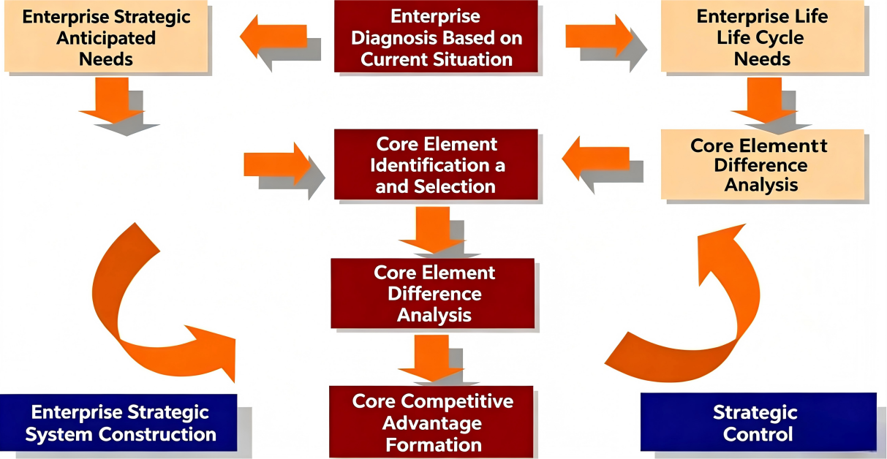
Corporate DNA is the genetic code of an enterprise. As a living non-natural organism, an enterprise has its own genetic genes, which are similar to human DNA. Human genes determine physical quality and development potential, while corporate DNA determines enterprise form, development and variation characteristics, and fundamentally defines enterprise scale, type and the health and orderliness of operation.
The proposition of the corporate DNA concept regards enterprise development as the growth of a living organism. The purpose of enterprise existence is growth rather than profit maximization; the premise of enterprise survival is creating value for customers. This returns the alienated and deviated enterprise development to its origin, so as to grasp the essence of enterprise development more clearly.
Building an evergreen enterprise that lasts for a century or even longer is not only the expectation of enterprise operators, but also an important research content of enterprise management theory. Ichak Adizes, a famous contemporary American management thinker, educator and founder of organizational health science, spent more than 20 years studying enterprise development, aging and decline. In his work Enterprise Life Cycle, he divided the enterprise life cycle into ten stages. The book summarizes the characteristics of different stages of enterprise life, clarifies the basic laws of enterprise life cycle, reveals the basic relationship between development and constraints in enterprise survival, and becomes a valuable reference for exploring enterprise success factors.
Exploring the success factors of enterprises and centennial enterprises is an important subject in enterprise management theory and practice. There are various research methods, and different research perspectives and entry points may lead to different conclusions. However, integrating these conclusions will reveal many commonalities. The reason is simple: any enterprise, regardless of industry, environment or development stage, if it grows into a centennial enterprise, must have inherent internal factors.
Taking human life as an example, a long-lived person relies on external objective factors and self-cultivation, while internal longevity genes, namely one’s own DNA, play a decisive role. In studying the success factors of centennial enterprises, we may borrow the concept of DNA and take typical global centennial enterprises as samples to explore their inherent DNA. The corporate DNA theory has at least three important values:
First, similar to SWOT analysis and Five Forces Model, corporate DNA provides senior enterprise managers with a thinking framework and paradigm. Through this framework, managers can inspect enterprise architecture, business processes, resource status and relationships with stakeholders, identify blocked links and operational bottlenecks, and conduct comprehensive and objective enterprise diagnosis to judge enterprise health status: healthy, sub-healthy, unhealthy or critically ill.
If an enterprise is healthy, it is necessary to further verify whether the current healthy state is fragile health. If unhealthy, it is essential to identify the crux, so as to take timely measures: take preventive measures to strengthen internal management and consolidate foundation; activate risk management and crisis management mechanisms to turn the tide; or maintain a sense of crisis to cultivate sustainable development capabilities. Many "unhealthy" enterprises have problems in the four basic elements, such as bloated institutions and complicated hierarchical layers, over-concentrated power and insufficient delegation, inconsistent policy implementation and passive implementation by subordinates, and scattered staff morale and low motivation.
Second, the corporate DNA theory tells us that evergreen and well-managed enterprises do not lie in scale, development speed or even opportunity grasping ability, but in cultivating high-quality inherent genes (DNA), enabling the enterprise to resist external "pathogen" erosion and achieve continuous growth. Enterprises should select high-quality "seed sources" at the initial stage of establishment, devote efforts to screening and cultivating superior genes to gain innate advantages and win at the starting line of competition. Meanwhile, in the acquired survival and development, adhere to the law of survival of the fittest to become a centennial enterprise.
Third, what if an enterprise is inherently deficient? Should it resign itself to fate and remain mediocre? The enlightenment of corporate DNA theory is that enterprises can carry out their own "bioengineering and genetic engineering", conduct artificial "genetic modification" or "transgene", obtain variation advantages through "genetic variation", targeted gene therapy or gene hybridization, and achieve long-term development.
In practice, introducing high-quality strategic investors can diversify investment subjects, restructure the board of directors, optimize corporate genes and governance structure. At a certain development stage, enterprises can also achieve fundamental transformation through capital market operation and property rights transactions. If necessary, introducing professional managers (teams) with high professional ethics can "replenish new blood", inject new vitality into the enterprise, enhance self-development capacity, and pursue sustainable development.
Plato said: "The first youth is given by God; the second youth is earned by oneself."The above four management systems and eight-capability model constitute the DNA genes of centennial enterprises, playing different roles in different stages of enterprise growth, and directly or indirectly affecting enterprise health and development. This paper will fully expand and analyze the connotation, so as to solve various problems faced by enterprises in the development process and inject evergreen DNA for enterprises to grow into centennial organizations.

1. Hidden Champions: The DNA of German Centennial Enterprises
Among 3.5 million enterprises in Germany, there are more than 800 centennial enterprises, 90% of which are family-run. The top 100 German family enterprises have an average age of over 90 years, all genuine century-old enterprises. When talking about German enterprises, people first think of industrial giants such as Mercedes-Benz, BMW, Volkswagen and Siemens. However, small and medium-sized enterprises account for 99% of all German enterprises, contributing 54% of economic added value and 62% of employment, and are the backbone of German industry.
Among these SMEs, there are about 1,400 hidden champions, known as "pearls scattered all over Germany". Among 3,500 global hidden champions, nearly half are from Germany, concentrated in medical technology, environmental industry, special equipment, chemical industry and electronic equipment.
The common strategic characteristics of hidden champions are: adopting niche strategy, focusing on a narrow segmented field to form sustainable competitive advantages; promoting organizational reform and innovation; inheriting corporate culture and team values through efficient internal information transmission; keeping pace with the times, promoting continuous organizational learning and self-transcendence; possessing strong execution, being quality-oriented, attaching great importance to core product quality and value, pursuing exquisite manufacturing; and giving full play to a robust command system to improve overall team leadership and decision-making capability. These leading centennial enterprises have laid a solid foundation for Germany's economy, quality brand and industrial success.

2. Innovation Gene Empowering the Inheritance of Centennial Enterprises
Innovation is an eternal theme of human society and an inexhaustible engine of economic and social development. The stable recovery of the global economy and the quality upgrading and efficiency improvement of China's economy all rely on innovation.
Innovation is the engine that maintains the vitality and prosperity of an enterprise, an industry and a national economy. For biological organisms, DNA undertakes the mission of replicating genetic codes and reproducing life. For enterprises, DNA is the core of corporate life, while innovation means changing the original arrangement and combination of corporate DNA from inside to outside, eliminating inherent damaged gene chains, realizing evolutionary progress, optimizing and developing the renewed DNA in enterprise life, and passing on enterprise vitality from generation to generation.

Figure 2 Corporate DNA Innovation Schematic Diagram
DNA mutation and innovation of Chinese enterprises is an irresistible general trend. As a new thinking, it emerges as the times require. The author advocates adopting unconventional methods to accomplish extraordinary undertakings, actively responding to the national initiative of mass entrepreneurship and innovation, providing business knowledge wealth for entrepreneurs and promoters, and promoting the healthy and sustainable growth of small and medium-sized enterprises. As an entrepreneurship coach, the author constantly proposes that entrepreneurs should select high-quality genetic seeds at the initial startup stage to possess strong vitality and competitiveness.
"Natural selection, survival of the fittest". Facing the fierce competition in the consulting and training industry, the author recently published the work The DNA Code of Centennial Enterprises Uncovered. Only by completing the upgrading of four major systems and eight capabilities can enterprises improve their resilience against uncertain environments and ultimately build core competitiveness. Only by continuous innovation and improvement of corporate DNA can enterprises last forever.
Innovation is the bright symbol of the new era and the ultimate antidote for enterprises to get rid of inherent chronic problems. We praise those who dare to create and innovate, for they will lead the whole industry and global economy out of downturn towards strong, balanced and sustainable development. Innovation means breaking the existing model, reorganizing various production factors, and reshaping value.

3. Implant Centennial Enterprise Genes to Build a Century-old Foundation
Corporate DNA is composed of four systems. The reason why corporate DNA is summarized into four systems is inspired by the principle that the biological double helix DNA is determined by different combinations of four nucleotide molecules.
Figure 3 Leadership Echelon: Four Systems and Eight Capabilities Mode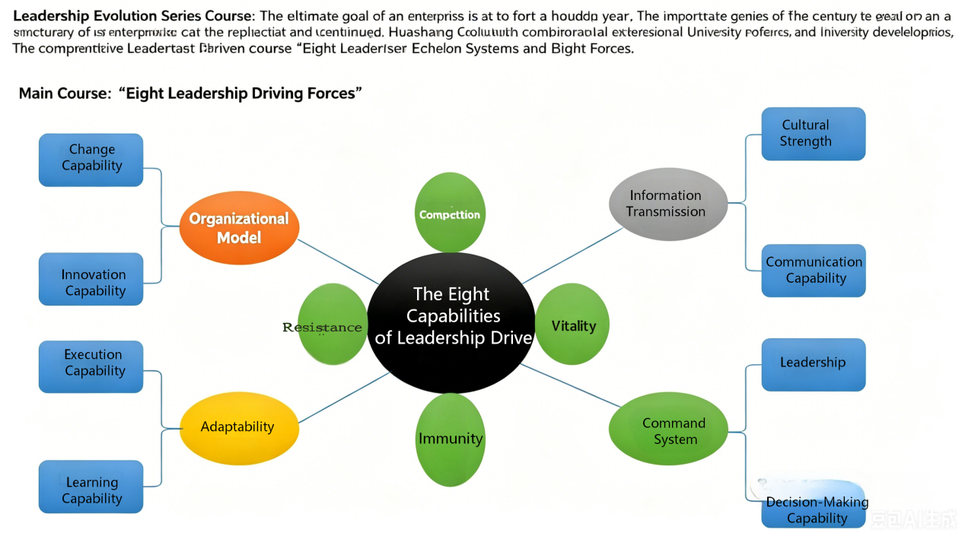

3.1 Four Basic Systems Determine the Vitality of Corporate DNA
Nowadays, the vitality of centennial enterprises has become a hot topic in global business management. Many senior enterprise managers feel distressed by the lack of effective vitality, and witness numerous enterprises fail to live long and close down. The author once saw a food enterprise in Tianjin hanging a banner on its opening day: Opening Today, Closing Date Unknown, which caused widespread repercussions.
An enterprise is also a living organism; poor operation will eventually lead to closure. The core viewpoint of this research is to explore how to help enterprises extend their lifespan through external forces.
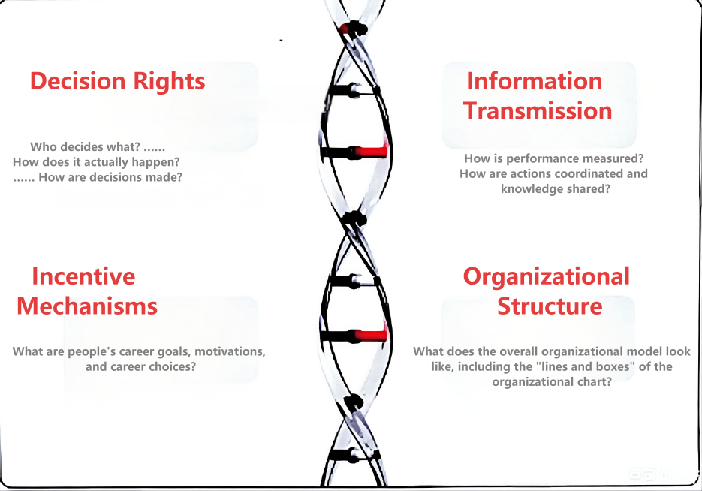
Analyzing enterprise vitality from the perspective of DNA transgenosis of living organisms, this research analogizes enterprise attribute characteristics to biological DNA. Just as the biological double helix DNA is composed of four nucleotide molecules, corporate DNA consists of four basic elements: organizational structure system, information transmission system, adaptation and incentive mechanism, and command and decision-making system. These basic elements form enterprise uniqueness through countless combinations. Hot topics such as strategy, innovation, vitality and enterprise transformation are all deeply rooted in enterprises’ inherent attributes.

3.2 Organizational Structure System
What is the organizational hierarchy? How are lines and boxes connected in the organizational chart? How many levels does the organization have? How many direct subordinates does each level have? Continuous organizational development requires internal learning, growth and development, and more importantly, detailed execution. Meanwhile, the organization must serve the strategy. Only by achieving strategic goals can corporate DNA adapt to environmental changes, carry out improvement and reform, and adjust measures to enterprise conditions.
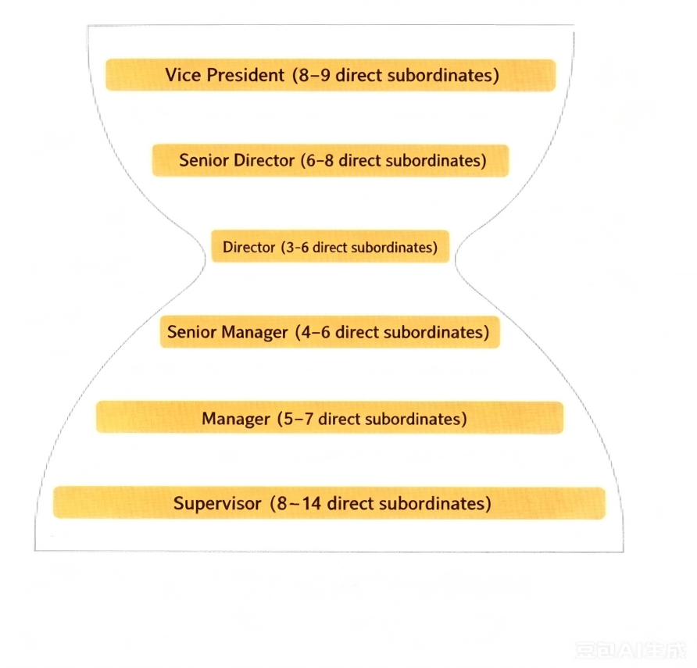
Figure 4 Hourglass Span Setting Diagram

3.2.1 Common Problems
Excess management levels, too many personnel at each level but too few direct subordinates (narrow span). Structurally, it presents an hourglass shape, usually caused by unclear decision-making power and unreasonable incentive mechanisms.

3.2.2 Case Analysis
This study compared the number of direct subordinates of department managers between a consumer goods company and several peer enterprises. The production line manager of the target company had 5 direct subordinates, while those of two high-performing enterprises had 7 and 10 respectively. The deputy general manager of sales had 6 direct subordinates, compared with 8 and 10 in peer companies. The manufacturing manager had only 7 direct subordinates, versus 11 or more in other companies.
This unreasonable structure restricted enterprise potential and caused the following problems:
- Senior managers spent about 40% of their time evaluating subordinates’ work afterwards and preparing reports for superiors, instead of focusing more on action plans.
- Even minor decisions such as computer procurement and travel arrangements were decided by senior management.
- Managers and supervisors restrained employees from discovering and solving daily work problems.
- Frequent job rotation of managers led to promotion to senior positions without sufficient working experience.
- Enterprises rapidly promoted outstanding employees to retain talents, resulting in unnecessary hierarchical layers and increased workload for grassroots employees.
- High remuneration for hired managers and operational waste made the enterprise’s general and management expenses 20% higher than the industry average.
- Almost all decisions involved participation of all levels, resulting in extremely slow market response.

3.2.3 Countermeasures
- Reduce management levels and expand management span, i.e., increase the number of direct subordinates for each manager. The optimized structure cut 10% of management positions, eliminated about 2,300 managerial posts, and saved 250 million US dollars for the enterprise.
- Formulate clear norms. Simply reducing levels and expanding span cannot generate long-term effects if grassroots staff act arbitrarily. Unified specifications can reduce repeated review by senior managers and allow them to focus on more important affairs.
- Revise the promotion plan, slow down hierarchical promotion, encourage lateral transfer, and fully communicate with managers on changes of promotion principles.
- Conduct management training to help employees adapt to organizational changes after streamlining management levels.

3.3 Information Transmission System
Human progress and development rely on DNA iterative replication and information transmission. The reason why century-old enterprises and hidden champions can pass down steadily without deviation lies in the inheritance of corporate culture, values and effective internal communication in corporate DNA.
Key research questions: What are the criteria for evaluating employee performance? How to adjust actions? How to organize employee training? Who knows what information? Who needs to know? How to realize information transmission from information owners to demanders?

3.3.1 Common Problems
Poor or insufficient internal information flow; business plans divorced from actual conditions.

3.3.2 Case 1
Farm managers of an agricultural enterprise used equipment at will, ordered machinery arbitrarily, and operated in a rough way, returning equipment with empty fuel tanks. Such phenomena occurred because equipment maintenance costs were solely borne by the headquarters. The enterprise’s expenditure was much higher than that of independent farms.
Countermeasure: Restructure the business model, divide each farm into an independent business unit, and assess performance through profit and loss statements that reflect equipment costs. After restructuring, the enterprise operated more efficiently, and its stock price surged by 48% within one year.

3.3.3 Case 2
All farms of the agricultural enterprise had a 15-day peak harvesting period, while harvesting and processing plans were formulated by headquarters staff based only on historical data, which often failed to reflect real situations.
Countermeasure: Authorize farm managers to reserve processing equipment independently according to real-time weather and crop maturity, avoiding blind judgment made by headquarters relying solely on historical data.

3.4 Adaptation and Incentive Mechanism
Genes are continuously updated to adapt to the external environment and progress in implementation. The history of centennial enterprises is a history of hundred-year changes, learning and growth, and the DNA of centennial enterprises is an evolutionary history of survival of the fittest.
Key research questions: What are employees’ career goals, job motivation and career choices? What performance deserves rewards? How to give material and spiritual incentives? What behaviors should be encouraged? Adopt direct or indirect incentive methods?

3.4.1 Common Problems
Distorted performance evaluation, unreasonable assessment standards, and confusing incentive information delivered to employees. In a consumer goods company, the performance evaluation system had 10 grades, and 80% of employees were rated Grade 9 or 10. Overly lenient evaluation demotivated outstanding employees and retained incompetent staff, weakening overall enterprise vitality.

3.4.2 Case 1
A large comprehensive agricultural enterprise intended to improve the service quality of the human resources department. The HR department’s performance was only assessed by budget compliance, rather than employee internal satisfaction. Even with poor service quality, employees had no feedback channels, and the HR department lacked the initiative to optimize services.
Countermeasure: Establish a scorecard system to evaluate HR performance through quantitative indicators such as waiting time of service hotline and salary payment error rate. Employees obtained the right to negotiate service standards with the HR department. Market-oriented evaluation improved service quality and reduced costs by more than 15%.

3.4.3 Case 2
The newly appointed CEO of a technology company found that the investment review committee lacked clear judgment in project approval. Committee members endorsed all investment applications to gain recognition, and bore no personal losses even if defective projects were approved.
Countermeasure: Bind decision-makers’ personal interests with decision outcomes. The CEO required each committee member to borrow 1 million US dollars personally to purchase corporate stocks (low-interest loans guaranteed by the company). Committee members became highly prudent in project review to avoid personal asset losses, improving the efficiency and rationality of investment approval.

3.5 Command and Decision-Making System
The DNA of living organisms consists of leadership decision-making mechanism and neural system. Similarly, in enterprise operation under big data era, core questions include: Who makes decisions? How many people participate in decision-making? How is decision-making power gained or lost? How to improve and develop leadership, all of which affect enterprise long-term stability.

3.5.1 Common Problems
Ambiguous decision-making power and responsibility; frequent arbitrary changes of decisions; poor cross-departmental collaboration; senior managers hold original power after promotion and refuse authorization, undertaking unnecessary grassroots responsibilities.

3.5.2 Case 1
After a leveraged buyout of a large industrial company, the management of a business department was upgraded to the parent company’s management and required to review all business decisions. Senior executives were accustomed to deeply participating in product design and resource allocation, ignoring more important work such as strategic planning, long-term business decision-making and overall financial status.
Countermeasure: Establish a clear mechanism to define decision-making power and jurisdiction, set up a special life committee to review business decisions, and delegate daily operation, marketing and product R&D to business department general managers to realize effective authorization.

3.5.3 Case 2
A consumer goods company held frequent senior meetings to resolve cross-functional conflicts. The operation, finance and marketing departments could independently analyze competitors, new products and market opportunities, but failed to coordinate when discussing together. The operation department formulated complete business plans without referring to financial cost data. Functional managers held independent analysis reports and argued repeatedly in meetings without unified conclusions.
Countermeasure: Assign a senior executive to take charge of cross-departmental team coordination, standardize communication mechanisms, and realize efficient synergy between functional departments.

Conclusion
Although the four systems of corporate DNA have different characteristics, they are closely intertwined and complementary. Optimizing organizational structure requires reforming decision-making power; effective decision-making requires new motivation mechanism and accurate information data to support enterprise development.
Corporate DNA provides senior managers with a logical framework to diagnose corporate problems and explore potential capabilities to adjust corporate behavior. Inspecting enterprise architecture, resources and partnerships through this framework helps managers identify ineffective links and bottlenecks, understand internal logic, and formulate optimization strategies. Reconstructing corporate DNA combines wisdom and decision-making capability, unifies internal common goals, and promotes efficient collaboration of all employees and departments.
No enterprise can completely solve all vitality problems, but the practice of evergreen and dynamic enterprises tells us that details determine success. Imagination is the path leading to a new world for centennial enterprises. Facing uncertainty, coping with unknown challenges requires imagination. The universe and the earth may perish in billions of years, let alone an organization or an enterprise. The conclusion is clear: there are no eternal immortal enterprises, only long-lived enterprises. The lifespan of current enterprises is generally short.

References
- Zhuang, Q. F. (2016). The Role of Information Communication in Enterprise Training Management. Architectural Engineering Technology and Design, 21.
- Cai, C. P. (2015). The Secret of Japanese Centennial Old Stores. Decision and Information, 8, 34-35.
- He, Z. Z. (2016). Building Century-old Brands Benchmarking German Enterprises —— Reflections on Training in Germany in 2015. China Civil-military Conversion Industry, 1.
- Li, G. D. (2015). How Enterprises Build Century-old Brands. Corporate Culture, 6, 46-48.
- Liu, X. Y., & Xu, L. Y. (2016). The Rise and Fall of Qiao Family Compound. Home and Overseas, 6, 45-47.

